**A REPORT ON DATABASE MANAGEMENT SYSTEM OF**

**SOUTH EAST BANK LIMITED**

**Course title: Database Systems Project / Fieldwork**

**Course No.: CSE 3102**

**Submitted By:**

Khandker M. Qaiduzzaman

ID: 110229

Rezoana Ahmed

ID: 110234

Somapti Mondal

ID: 110251

**Submitted To:**

Dr. Md. Anisur Rahman

Professor

CSE Discipline

Khulna Univesity

Md. Zahidul Islam

Assistant Professor

CSE Discipline

Khulna University

Khulna University

Date of Submission: May 12, 2014

**ABSTRACT**

The project is about to design Database Management System (DBMS) of Southeast Bank Limited, Bangladesh. Database Management System is a software system that uses a standard method of cataloging, retrieving, and running queries on data. The DBMS manages incoming data, organizes it and provides ways for the data to be modified or extracted by users or other programs. The Bank Management System is an application for maintaining a person’s account in a bank. The system provides the access to the customer to create an account, deposit/withdraw/transfer the cash from his account and to view reports of all accounts present also. The project focused on designing robust database design and a common desktop application for admin, employee and user with necessary access permission. A user friendly user interface (UI) was developed to make the system complete and effective but easy.

**Keywords:** DBMS, BMS, Database, Query, UI, E-R, Diagram, System, Design.

**CHAPTER 1**

**INTRODUCTION**

* 1. **Overview**

The domain “Banking System” keeps the day by day tally record as a complete  
banking. It can keep the information of account type, account opening form, deposit,  
withdrawal, and searching the transaction, transaction report, individual account  
opening form, group account. The exciting part of this project is, it will display transaction  
reports, statistical summary of account type and interest information.

* 1. **Objective**

To design a complete bank management system software and database management system for Southeast Bank Limited, Bangladesh.

* 1. **Scope of Project**
* To collect the required information and data from the related bank.
* To design an Entity Relationship Diagram from the relevant data.
* To design the relational table and set integrity constraints from the E-R Diagram.
* To find out possible queries from the tables.
* To develop a common user interface for admin, employee and user.
* To implement the database management system in the application and connecting it with the user interface.

**1.4 Problem Statement**

A bad bank management system design has data redundancy, inconsistency, concurrent access anomalies, integrity problem and security problem. Moreover, a bad database design leads the software to crush and become slower. In this project, a better database design has been implemented which is faster, easier, optimized but efficient and complete.

**CHAPTER 2**

**LITERATURE REVIEW & TOOL CHAIN**

**2.1 Introduction**

In order to design a complete bank management system, there needs sophisticated tools that helps to do things in easier way. In this project, the user interface was designed using Windows Presentation Foundation (WPF) form of Microsoft Visual Studio 10, C# .NET as programming language and MySQL for database.

**2.2 Microsoft Visual Studio 10**

Microsoft Visual Studio 10 is an integrated development environment (IDE) from Microsoft. It is used to develop computer programs for Microsoft Windows superfamily of operating systems, as well as web sites, web applications and web services. Visual Studio uses Microsoft software development platforms such as Windows API, Windows Forms, Windows Presentation Foundation, Windows Store and Microsoft Silverlight. It can produce both native code and managed code.

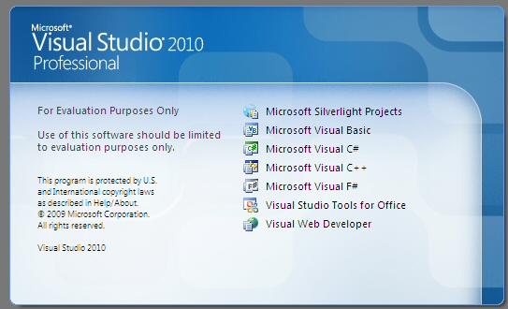

Figure 1 Microsoft Visual Studio 10

**2.3 MySQL Database**

MySQL is the world's most popular open source database software, with over 100 million copies of its software downloaded or distributed throughout its history. With its superior speed, reliability, and ease of use, MySQL has become the preferred choice for Web, Web 2.0, SaaS, ISV, Telecom companies and forward-thinking corporate IT Managers because it eliminates the major problems associated with downtime, maintenance and administration for modern applications.

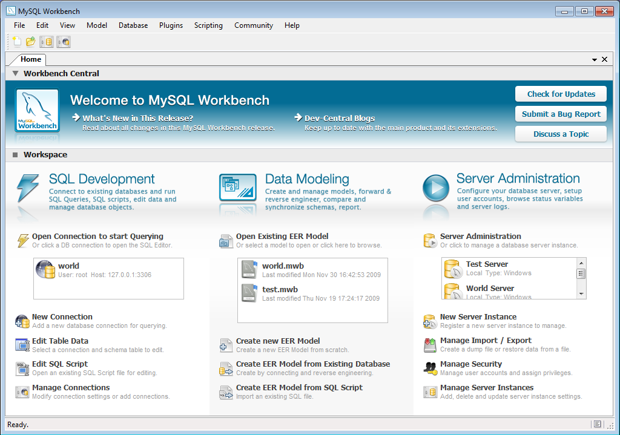

Figure 2 MySQL Workbench

**CHAPTER 3**

**METHODOLOGY**

**3.1 Introduction**

The project work was approached with the basic design of the database. In order to make a database system stand, all available data was collected from a particular bank; in this case Southeast Bank Limited, Bangladesh. From collected information and data, an E-R Diagram was designed. Afterword generalization and normalization was implemented to the diagram. According to the E-R Diagram, relational tables were designed and integrity constraints were set. Some queries were run on the database to check its functionality.

**3.2 Data Collection**

The following data and ideas were collected from the related bank. A field work was conducted to find out how a bank management system works.

* + 1. **General information**

There are personal information of every customer and employees in database. The important fields are –

Name (Short Name, First Name, Middle Name, Last Name), Address (Holding No., Street, Village, Sub-district, District, Division, Country, Postal/Zip Code, Phone no., Mobile No.), Date of Birth, Sex, Marital status, Race, Profession, Business type(for corporate customers), Nationality, National ID, Passport No., TIN, Spouse Name, Father’s Name, Mother’s Name, Photograph, Account No., Customer ID etc.

* + 1. **Account Types**

In general, there are four types of account are provided to the customers –

1. **Current Account:** 6% interest is provided on this type of account.
2. **Savings Account (Pension Savings, Monthly Savings):** There is also 6% of interest on this type of account.
3. **Time Deposit/ Fixed Deposit Account:** Fixed deposit account provides 10% of interest for 1 year, 11% interest for 2 year and 12% interest for 3, 6 and 12 year deposit of money.
4. **Short Term Deposit Account:** There is no interest is provided on this type of account.
   * 1. **Loan Types**

There are many kind of loan are provided to the customers depending on the category of the bank. General loans given by the commercial banks are -

1. **Business loan (OD):** Loans are provided depending on the type of business.
2. **Time Loan:** Customer can take 80% loan of the equivalent value of the total property and the property is kept as mortgage.
3. **Consumer Loan:** A customer can take loan upon his fixed deposit account.
4. **Retail Loan:** Customer can take special type of loan from the bank. The loans are taken for specific reason like – Personal Loan, Car Loan, Home Loan, Education Loan etc.
5. **Agricultural Loan:** This is an optional type of loan that is provided by some banks. Normally, bank provides BDT. 10,000 to 50,000 to a farmer for 2 years.

**3.2.4 Transaction**

Transaction happens in many ways. It could be done by cheque, Credit/Debit Card, Online Transfer, Telegraphic Transfer etc. Bank provides generally three types of smart card to the customers for transaction-

1. **Debit Card:** Customers get a debit card after opening an account.
2. **Credit Card:** Credit cards are given to the customers who have a certain amount of money deposited. Normally, bank provides a credit card of BDT. 1 lac upon BDT. 10 lac of deposit money.
3. **International Card:** International cards are given upon a certain amount of deposit money and the customer has to fulfill some requirement to be VIP for the bank.

**3.3 E-R Diagram**

According to the data and information stated above in Data Collection section, the following E-R Diagram was designed –

* 1. **Relational Table**

A sample of the relational table is given below-

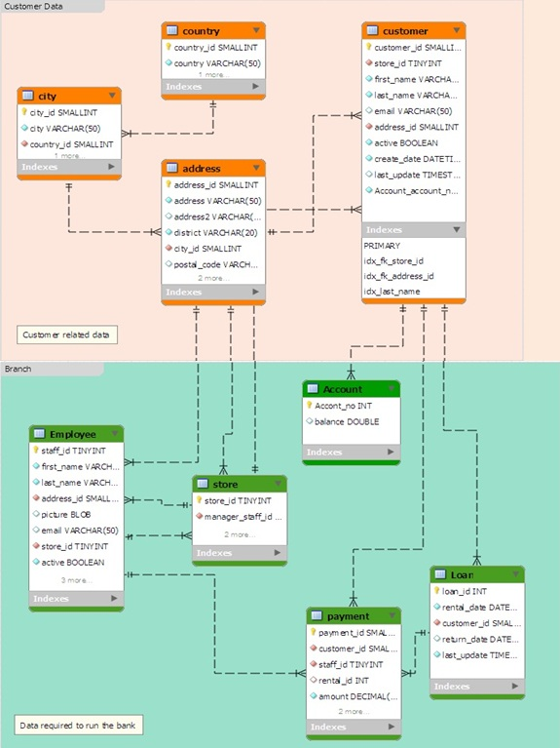

Figure 3 Relational Table of DBMS.

**3.5 Queries**

To check the proper functionality of the database some queries were done on the database –

Search all information of customers from Customer Table: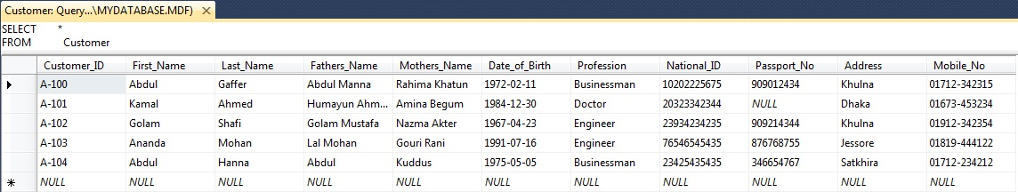

Search Customer_ID, First_Name and Last_Name of all customer from Customer Table:

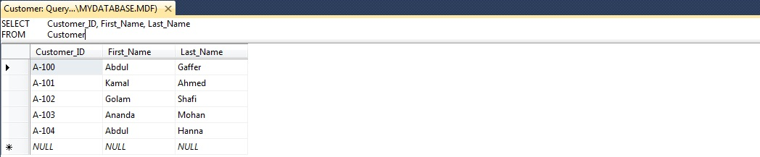

Search Customer_ID and Date_of_Birth of a customer whose Last_Name is ‘Gaffer’ from Customer Table:

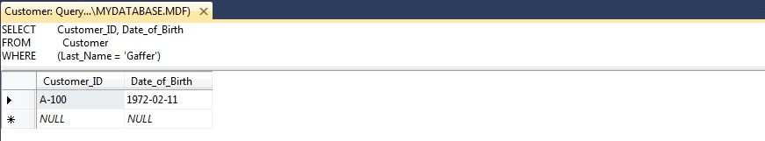

Insert values in Account_No, Balace and Account_Type of a customer:

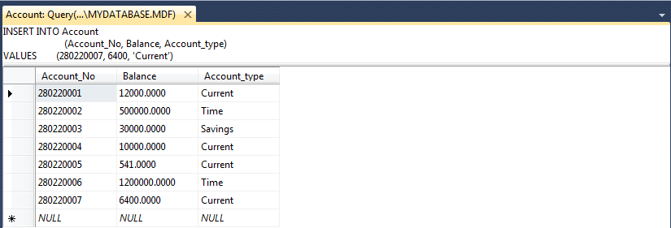

Delete all data of a row from Account Table where Account_No is ‘280220007’: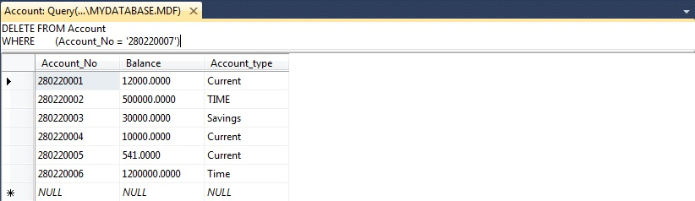

Search Customer_ID, First_Name, Last_Name, Father’s_Name, Mother’s_Name, Date_of_Birth, Profession and Address Ordered by Last_Name:

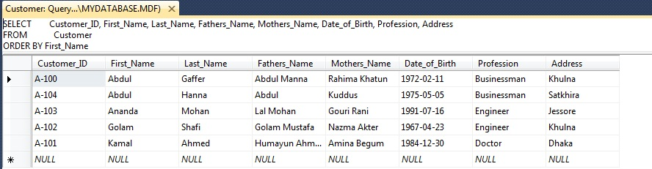

**3.6 System design**

In real world application for bank management, many types of system designs are followed. There may have different application for client, admin, and employee. There may have web application in addition to desktop application. All that design depends on system designer and bank authority. For simplicity, in this project there is one application with different user 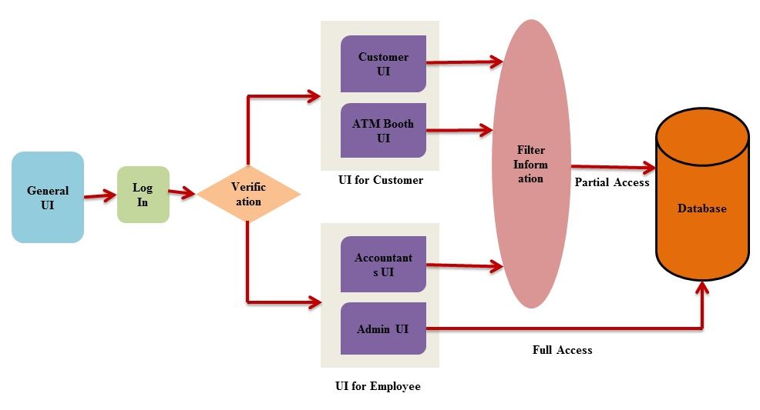interface. The whole process is described below-

* + 1. **General UI:** A general UI will be provided to all user. This UI shows the general features to customers and employee both. The application requires log in mandatorily. Now, before log in, the application determines whether he is admin, client or employee from his/her username. Username is the key to verify the type of the user. Any kind of wrong information gives error report with appropriate suggestions.
    2. **Verification:** Depending on the types of user, there is a mechanism that verifies the user. After verification, the mechanism will provide appropriate user interface to the user.
    3. **User Interface:** Customer can access the system either by going to the bank or ATM booth. There will have different user interface –

1. UI for Admin.
2. UI for Employee.
3. UI for Client.
   * 1. **Filer Information:** There is a filtering mechanism. It will provide full access in database to the admin and partial access to the employee and the customer. Admin will have full control of modifying all data. Confidential data will be hidden from customer or employee.
     2. **Database:** All the information of the banking system is preserved in database tables. The relationship between the entities provides appropriate information to the user.
   1. **Software Design**

A desktop application is developed to ease the data access. As different application for admin, employee and client causes complexity, there is a general application which automatically determines the category of user and depending on that a different UI is provided to the user with sufficient user access.

* + 1. **Log In Window**

This window lets the user to insert a valid user ID and Password. When the user presses the Log In button, the user ID and Password given by user is verified from database. If any wrong information is inserted, an error report is shown in massage box. Moreover, the backend code checks the user’s category – admin, employee and client. Depending on the category of the user, different window is popped.

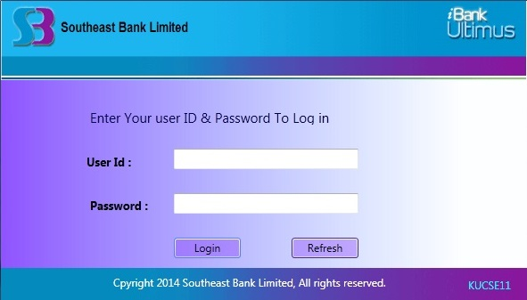

* + 1. **Home Window for Admin**

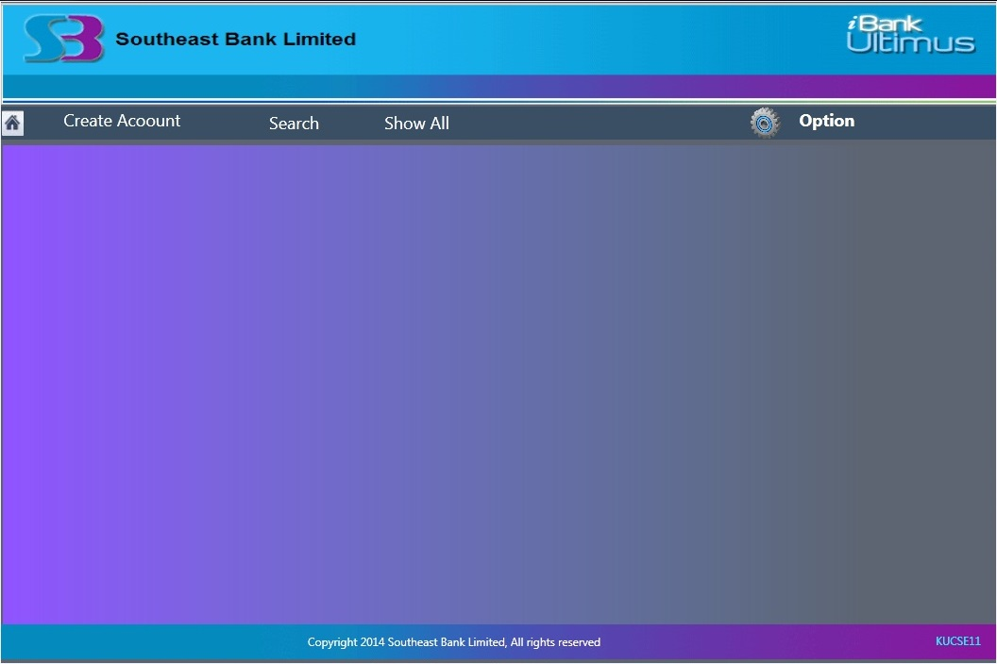

In this window there are some menu items on the above grid –

1. **Home**

If the home menu is clicked the window is cleared and comes to initial position.

1. **New Account**

If new Account menu is clicked Create New Account Window pops up –

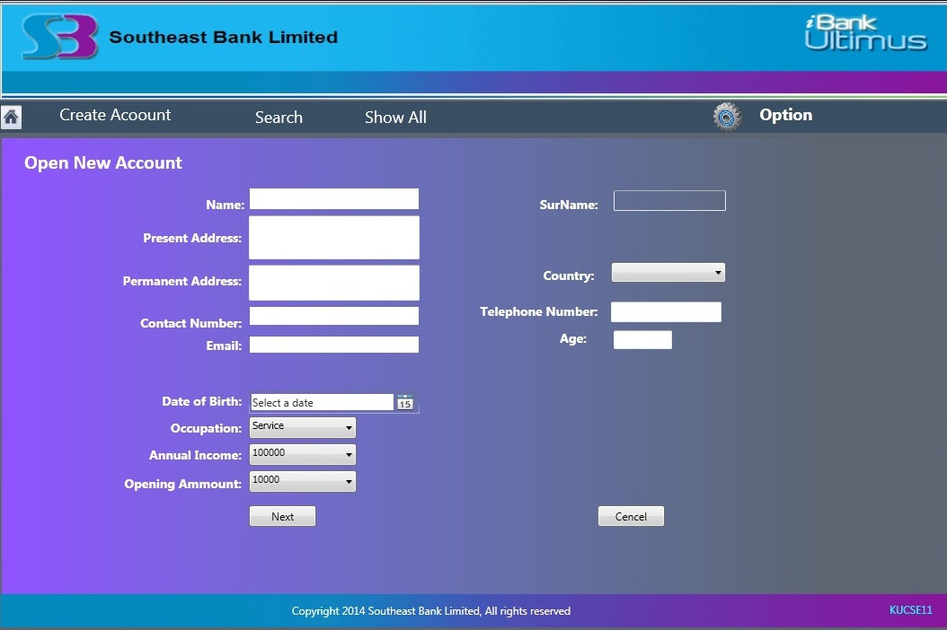

This window contains information fields of a customer. There is two button – next and cancel. If cancel button is clicked the window returns to home window. If next button is clicked Log in Information Window pops up.

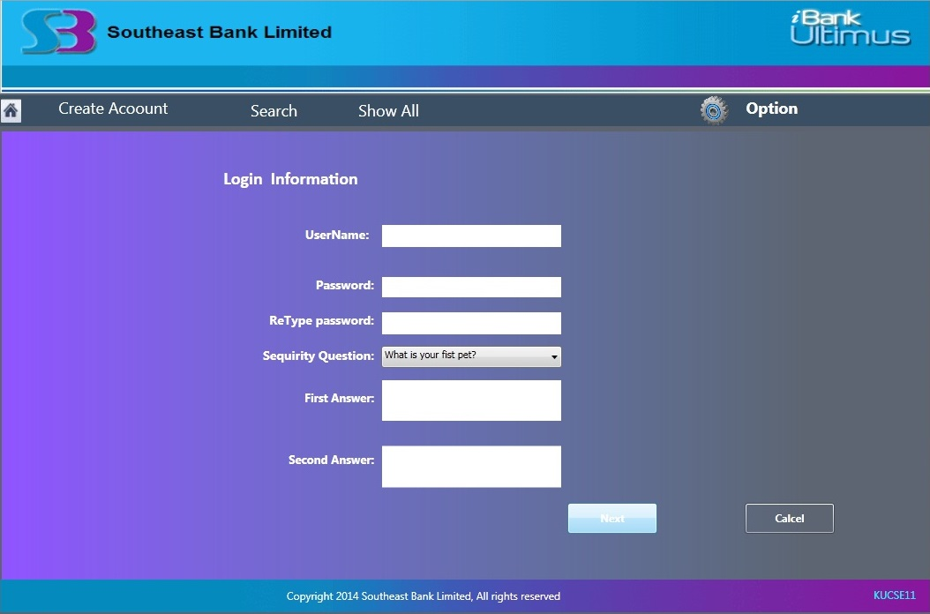

Customer has to fill up the required field. There is also two buttons – Next and Cancel. If cancel button is clicked the window returns to the previous window.

1. **Search**

If this menu is selected, search window pops up. User has to select the account number and press search button to find out the related information of that account number. If delete button is pressed all the information of that account number is deleted from the database.

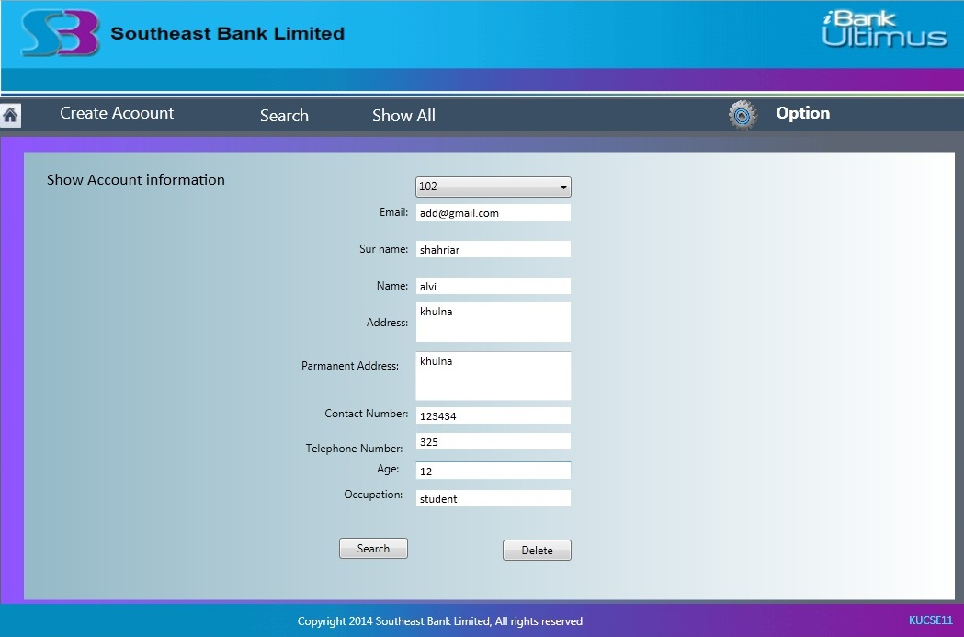

1. **Show All**

If this menu is clicked Show All Window pops up. In this window user can check three options – Client, Depositor and Borrower. If Client check box is selected, the data grid views all information of all customers. If Depositor is checked only the information of the clients who deposits money is shown. If Borrower is checked only the information of the clients who takes loan is shown.

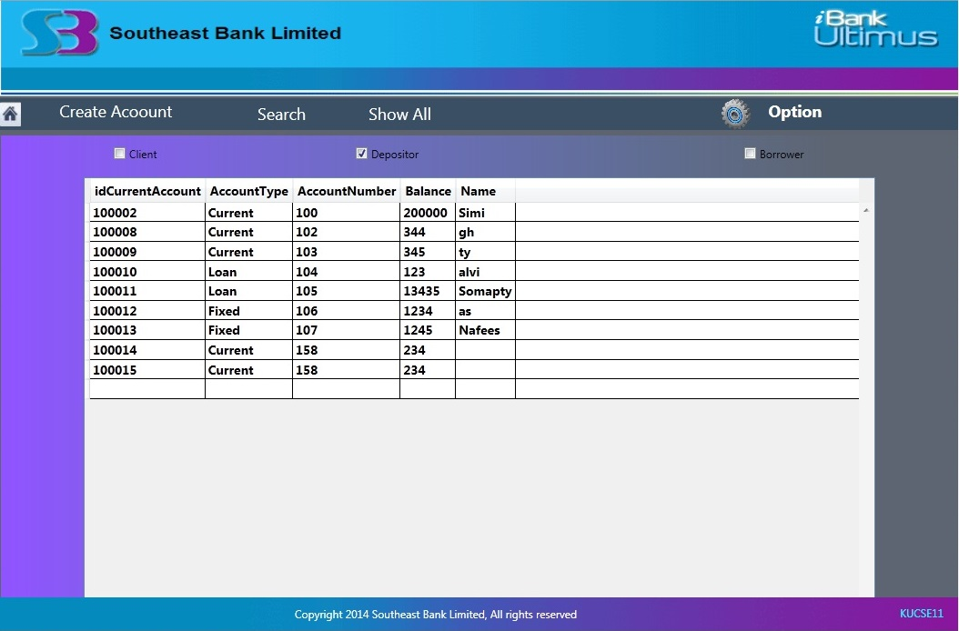

1. **Option**

From this menu user can log out from the application.

* + 1. **Home Window for Employee**

If the user is an employee, Home Window of Employee pops up. It contains 7 menus -

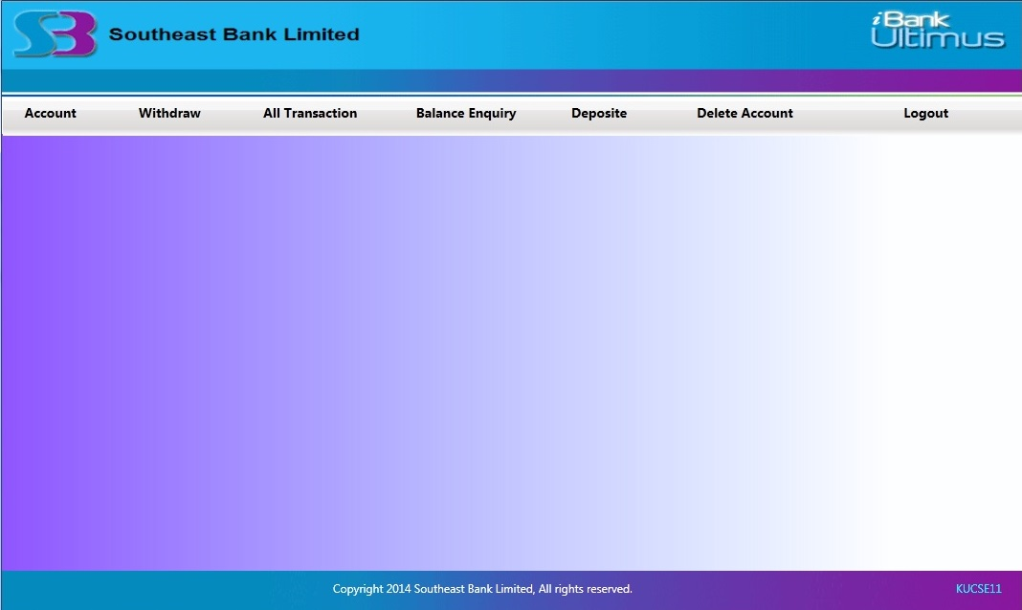

1. **Account**

It Account menu is selected New Account Window pops up. Its functionality is same as the admin’s New Account Window.

1. **Withdraw**

From this menu, employee can withdraw balance for a customer. For this, he has to insert the account number, amount and press Withdraw button.

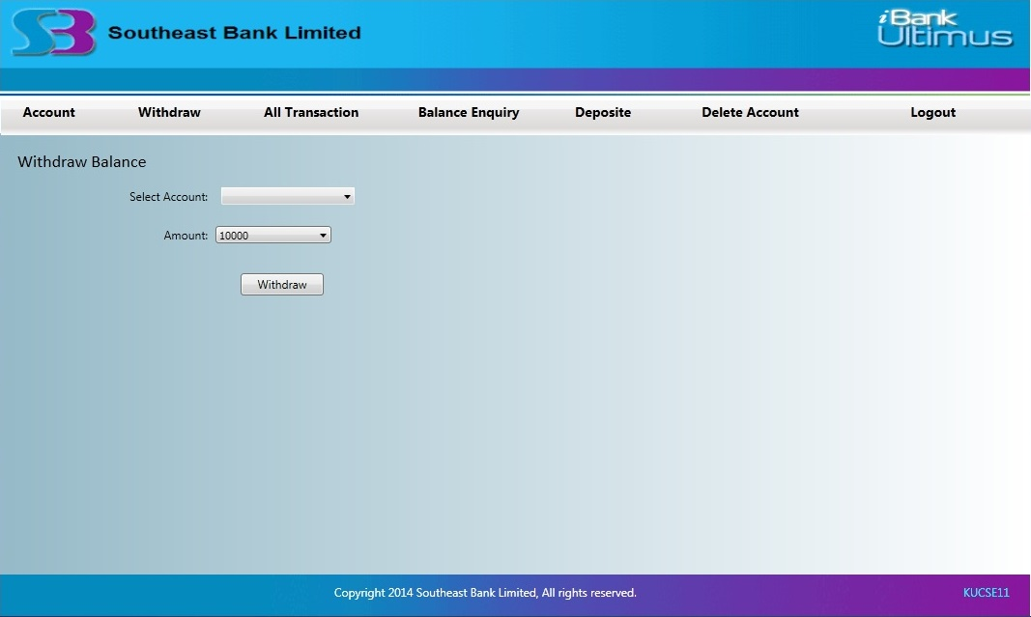

1. **All Transaction**

All Transaction menu shows all transaction details including date and time taken from system clock.

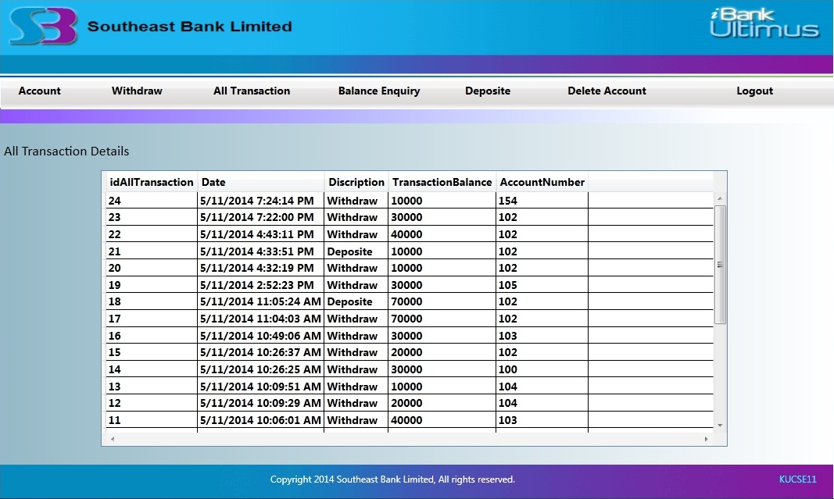

1. **Balance Enquiry**

Employee can check a customer’s balance. In order to enquiry, he/she has to input the account number and press Check Balance button. As a result, account holder’s name, account balance and all transaction details of the related account is shown.

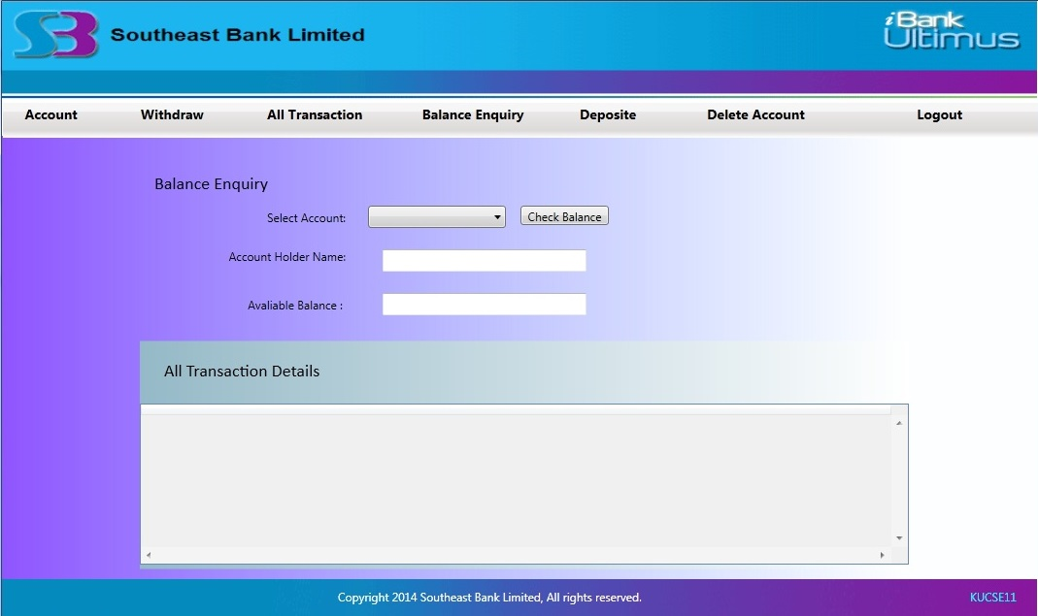

1. **Deposit**

To deposit a customer’s account employee selects Deposit menu. From this menu, he/ she inputs account number, amount and press Deposit button to complete the operation.

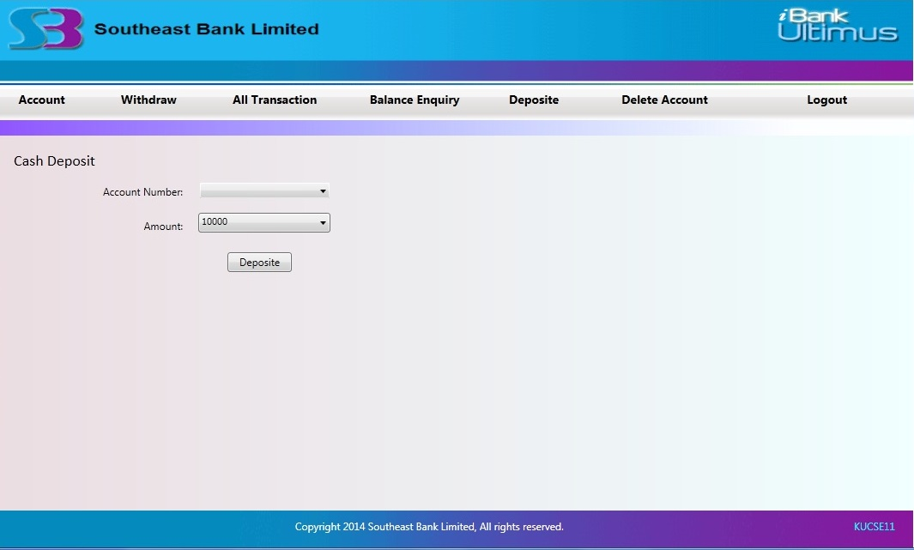

1. **Delete Account**

From this menu, an employee can delete a customer’s account by giving account number as input and pressing Delete Account button.

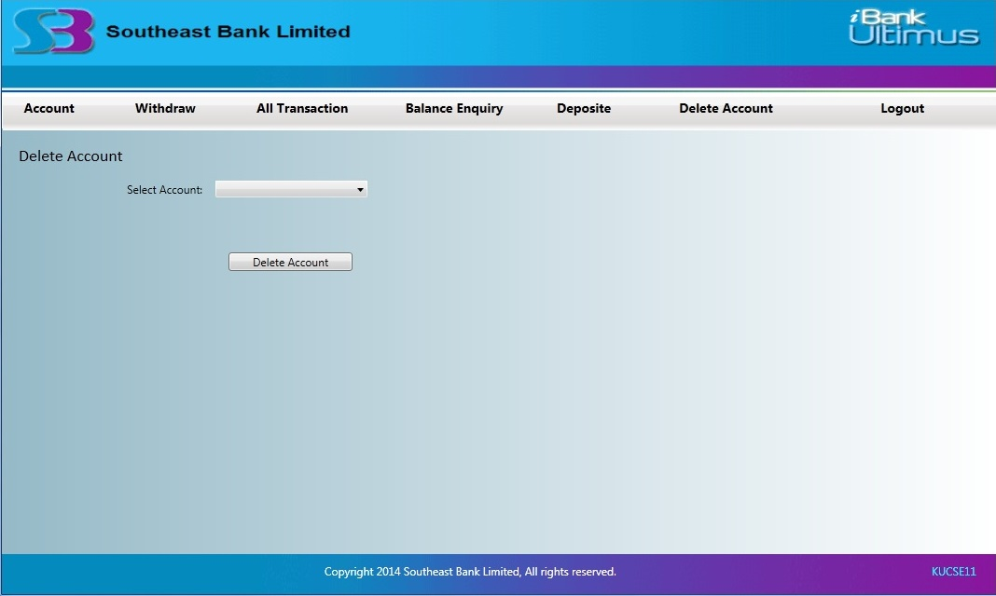

1. **Logout**

Employee can logout by pressing this menu.

* + 1. **Home Window for Customer**

If the user is a client, the Home Window for customer pops up. It holds four menus -

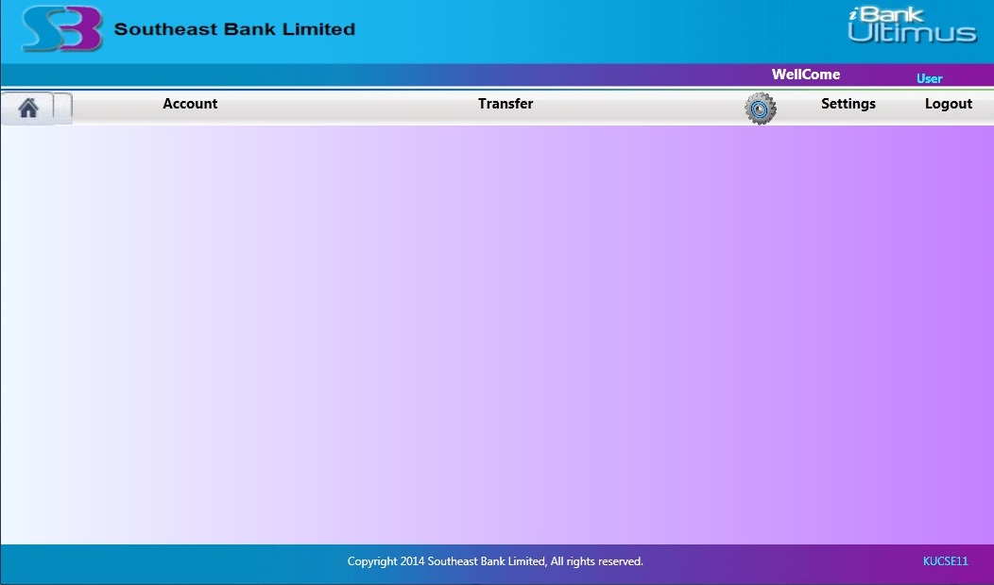

1. **Account**

From this menu client can view his/her account summary.

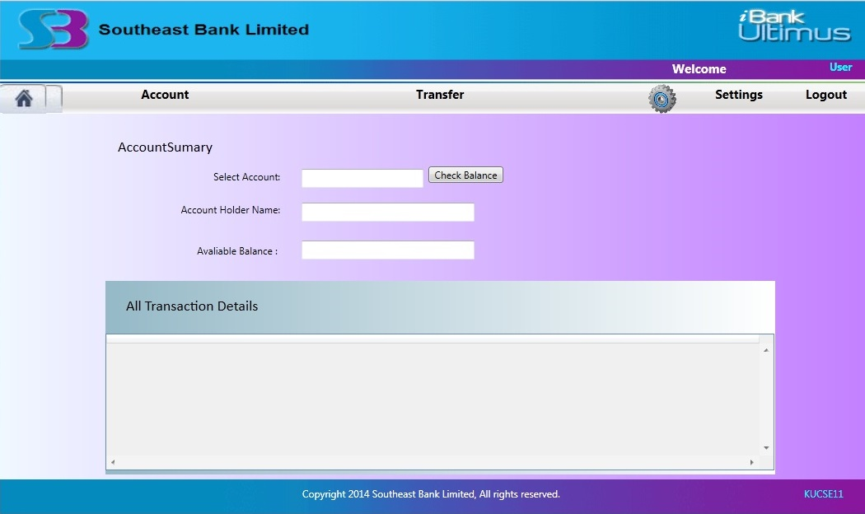

1. **Transfer**

Customer can transfer balance to another account from

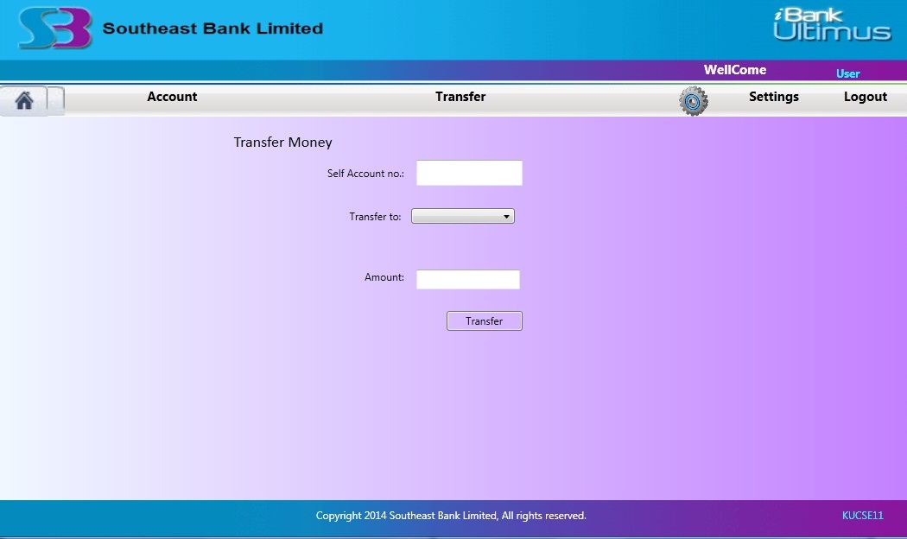

**CHAPTER 4**

**CONCLUTION**

Though it is tough to get the attributes of a bank management system database from the banks for security issue, the project used general outline of banking system. But, there is kept option for modification. Future plan of this project is to expand its scope to online application.

**CHAPTER 5**

**REFERENCES**

1. Taslima Khatun, South East Bank Limited, Haji Hanif Complex (1st floor), 12 & 13, Khan Jahan Ali Road, Khulna
2. Bangladesh Bank – Credit Information Bureau.
3. United Commercial Bank Limited, Khan Jahan Ali Road Branch, Khulna
4. Dutch Bangla Bank Limited Useful Forms - <http://www.dutchbanglabank.com/electronic_banking/forms.html>
5. Bank Management System –

<http://www.slideshare.net/vivekk1989/bank-management-system-1852764>

1. JAVA J2EE Tutorial – Enterprise Beans –

<http://ulm.uni.udm.ru/~oam/j2ee/tutorial/1_3-fcs/doc/Ebank2.html>

1. BankSystemVedio.mp4

<http://www.youtube.com/watch?v=oDKvwBWBIbc>